Image | 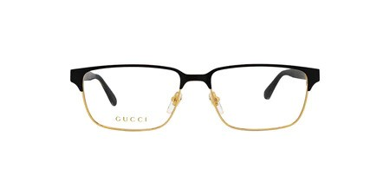
Brand | GUCCI
Model Name | GG 0383O
Price | RS 1449
PRODUCT DETAILS

